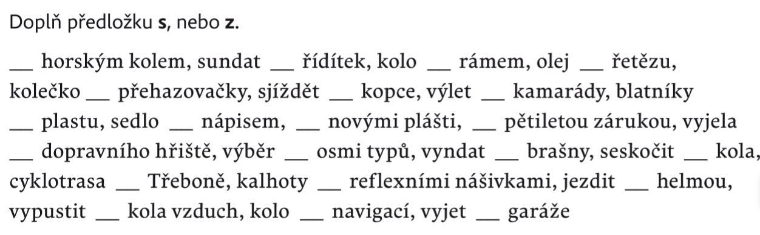TDÚ do 11. 4. Jméno:_________________



________________________________________________________________________________________________________________________________________________________________________________________________________________________________________________________________________________________________________________________________________________________________________________________________________________





____________________________________________________________________________________________________

__________________________________________________

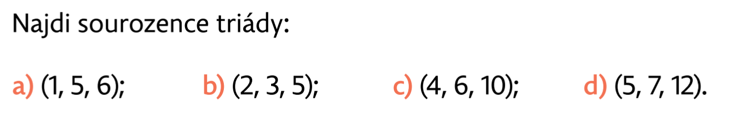

__________________________________________________

__________________________________________________

__________________________________________________

__________________________________________________

Narýsuj pravoúhlý trojúhelník, jehož jeden úhel má velikost 60°